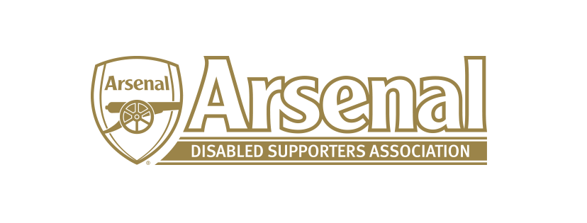

Arsenal Disabled Supporters’ Association
2018 Annual General Meeting

on Sunday 6th May at 2.00pm
at The Hub, Arsenal FC, 56 Benwell Rd, Islington, N7 7BA

Agenda

- Welcome and Introductions (Anthony Joy)

- Apologies for Absence

- Approval of Minutes of 2017 AGM

- Chair’s Report (Anthony Joy)

- Secretary’s Report (Anne Hyde)

- Treasurer’s Report (Nicole Evans)

- Communication (James Warren)

- Election of Committee

- Proposed Priorities (Anthony Joy)

  - New Magazine

- Questions from the Floor

- Any Other Business

