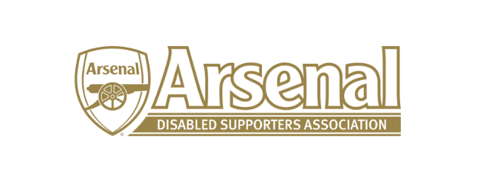
Arsenal Disabled Supporters’ Association
Notice is hereby given that there will be a meeting of Arsenal Disabled Supporters’ Association on Thursday 11th January 2018 at 7.30pm via Skype.
Committee
Anthony Joy (Chairman)
Anne Hyde (Secretary)
Nicole Evans-Dear (Treasurer)
Ozi Kemal (Media Officer)
Allan Mabert (Visual Impaired Representative)
Bob Greig (Committee Member)
Redmond Kaye (Hearing Impaired Representative)
James Warren (Newsletter Editor)
Tom Head (Ambulant Representative)

Agenda
- Apologies for absence
- Approval of minutes of previous meeting
- Matters arising from previous meeting
- Finance (NE-D)
- Membership update (AH)
- Health and Safety at the Emirates (AJ)
- Raffle (AH)
- Newsletter (JW)
- AOB

Date of next two meeting (both meetings are subject to change due to TV):
- Saturday 10th March 2018 prior to match (please note this date is subject to change)
- Saturday 5th May 2018 prior to match

