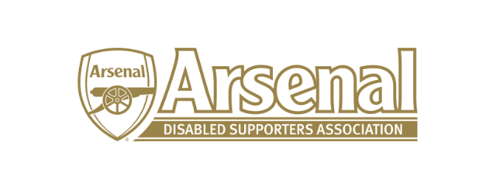
Arsenal Disabled Supporters’ Association
Notice is hereby given that there will be a meeting of Arsenal Disabled Supporters’ Association on Thursday 21st September 2017 at 7.30pm via Skype.
Committee
Anthony Joy (Chairman)
Anne Hyde (Secretary)
Nicole Evans-Dear (Treasurer)
Ozi Kemal (Media Officer)
Allan Mabert (Visual Impaired Representative)
Bob Greig (Committee Member)
Redmond Kaye (Hearing Impaired Representative)
James Warren (Newsletter Editor)
Tom Head (Ambulant Representative)

Agenda
- Apologies for absence
- Approval of minutes of previous meeting
- Matters arising from previous meeting
- Finance (NE-D)
- Membership update (AH)
- Newsletter (JW)
- Transfer of Away Credits (AH)
- AOB

Date of next meeting: Saturday 16th November (Venue / Time and date to be confirmed) – Face to Face Meeting

