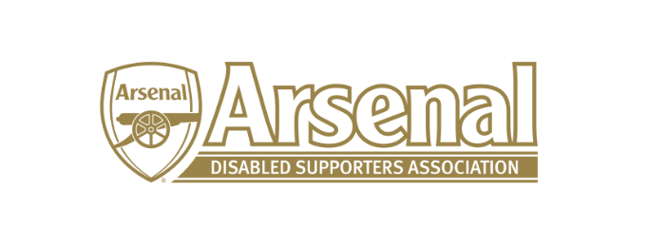
Arsenal Disabled Supporters’ Association
Notice is hereby given that there will be a meeting of Arsenal Disabled Supporters’ Association on Thursday 29th November at 8pm via Skype.
Committee
Anthony Joy (Chairman)
Anne Hyde (Secretary)
Nicole Evans (Treasurer)
Ozi Kemal (Media Officer)
Allan Mabert (Visual Impaired Representative)
Bob Greig (Committee Member)
Redmond Kaye (Hearing Impaired Representative)
James Warren (Newsletter Editor)
Tom Head (Ambulant Representative)

Agenda
- Apologies for absence
  - Tom Head
  - Redmond Kaye
- Approval of minutes of previous meeting
- Matters arising from previous meeting
- Finance (NE)
  - Deposits and Payments
  - Raffle
  - Introduction of Membership Fees (JW)
- Chairman’s Update (AJ)
  - Premier League Advisory Group
  - CAFÉ Conference
  - New Arsenal website
  - Update from meeting with Disability Liaison Officer
  - Evacuation Procedures
  - Survey
  - Banner
- Secretary’s Update (AH)
  - Membership update
  - Emails received regarding match on 11th November against Wolves
  - Email received regarding Hearing Impaired and ambulant having to stand in matches
  - Update - Level Playing Field Meeting
  - Season Ticket Waiting List
- ADSA – Way forward (JW)
  - Short term and long term goals – 3 or 5 year plan
  - How will we implement them
  - What do members want
  - Commitment to ADSA / Prepared to stand for a further term (AH)
- Official Arsenal Supporters’ Club Scheme (AH)
  - Discount on Line
  - Membership Cards
- Proposal of moving away from Newsletters to the Website (AJ)
  - How does the website need to be developed to make this proposal work (JW)
  - The Committees overall vision for ADSA communication and how best to implement it (JW)
  - Proposal to work with a University or College to build a more accessible website (AH)
- Any Other Business
- Meetings
  - Date of next meeting
  - Agree dates to the end of December 2019

