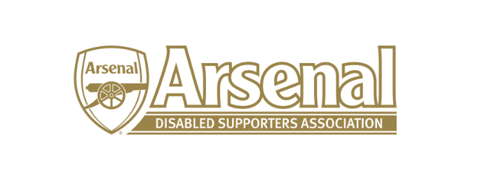
Arsenal Disabled Supporters’ Association
Notice is hereby given that there will be a meeting of Arsenal Disabled Supporters’ Association on Thursday 30th August 2018 at 7.30pm via Skype.
Committee
Anthony Joy (Chairman)
Anne Hyde (Secretary)
Nicole Evans (Treasurer)
Ozi Kemal (Media Officer)
Allan Mabert (Visual Impaired Representative)
Bob Greig (Committee Member)
Redmond Kaye (Hearing Impaired Representative)
James Warren (Newsletter Editor)
Tom Head (Ambulant Representative)

Agenda
- Apologies for absence
- Approval of minutes of previous meeting
- Matters arising from previous meeting
- Finance (NE)
  - Deposits and Payments
- Chairman’s Update (AJ)
- Secretary’s Update (AH)
  - Membership update
  - Correspondence
- ADSA – Way forward (All)
- Official Arsenal Supporters’ Club Scheme (AH)
  - Discount on Line
  - Membership Cards
- Newsletter
  - September Newsletter (JW)
- Website
  - New Website Address
  - How to make the website more accessible
- Any Other Business
- Meetings
  - Date of next meeting
  - Agree dates to the end of December 2019

