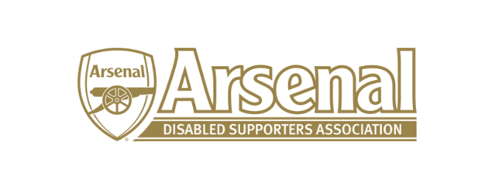
Arsenal Disabled Supporters’ Association
Notice is hereby given that there will be a meeting of Arsenal Disabled Supporters’ Association on Thursday 4th May 2017 at 7.30pm via Skype.
Committee
Anthony Joy (Chairman)
Anne Hyde (Secretary)
Nicole Evans (Treasurer)
Ozi Kemal (Media Officer)
Allan Mabert (Visual Impaired Representative)
Bob Greig (Committee Member)
Redmond Kaye (Hearing Impaired Representative)
James Warren (Newsletter Editor)

Agenda
- Apologies for absence
- Approval of minutes of previous meeting
- Matters arising from previous meeting
- AGM
  - Arrangements
  - Nominations for positions on the Committee
  - Agenda
  - Any other matters relating to the AGM
- Date of next Meeting
Note: This meeting will only be focusing on the AGM

