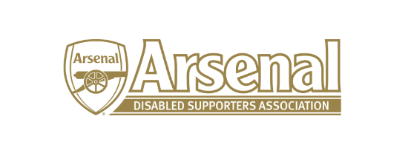

Arsenal Disabled Supporters Association

Committee Meeting

held on Friday 12th April 2019 – Skype Meeting at 7.30pm

Present: Anne Hyde (AH)
James Warren (JW)
Anthony Joy (AJ)
Tom Head (TH)

 | Item |  | Who to Action
1 | Apologies for Absence | Nicole Evans-Dear (NE-D) and Alan Mabbert (AM)
2 | Approval of minutes of previous meeting | The minutes for the 13th March to be approved at the next meeting.
3 | Matters Arising from previous meeting | None
4 | Finance | The current account stands at £1,073.41 with no outgoings.
5 | Strategy Meeting with Arsenal FC and Level Playing Field | AJ had met with Alun Francis (Disability Liaison Officer) following the strategy meeting. It had been agreed that:  - Gold and Purple members will be targeted for the survey. There would be one survey with a question at the start asking whether the person is a Gold or Purple Member followed by 20 generic questions. There would then be 10 questions specific to the type of disability (Hearing Impaired, Visually Impaired, Wheelchair user, Ambulant and Sensory. AJ had been sent surveys that had been previous been used from Level Playing Field and the Disability Liaison Team and AJ will send these to the committee. It is recognised that the experiences for different people and members will be different e.g. the way members book on line. AJ asked if questions could be produced by TH for Ambulant, JW for Wheelchair, RK for Hearing Impaired and AM for Visually Impaired. It is recognised that some members will have more than one disability so they should pick the most relevant. These questions to be produced by the end of April and sent to AJ to collate. The Committee to think about what generic questions should be asked and sent to AJ. The survey will be distributed to the Committee prior to distribution by the Disability Liaison Team – expected date of distribution will be June.  - The Disability Liaison Officer had received sign off for a Customer Service relay link for Hearing Impaired supporters.  - The Disability Liaison Team is looking to reduce the recurrent proof of disability each year for Season Ticket Holders / Purple Members.  - AJ has been asked to take part in some digital filming on the 3rd May which may require further supporters to attend.  - It was agreed that a separate meeting regarding the Disabled Supporters page on the Arsenal website would take place and JW and AH to meet with Alun Francis (DLT).  - The Access Statement is accurate but needs reviewing which is currently being looked at by the DLT.  - AJ is user testing the booking of parking / tickets / coach travel on the 16th April.  - It was agreed that the Away Scheme required clarity, and this would be raised as part of the review of the Disabled Supporters page. | AJ  TH / JW  RK / AM  AH / JW
6 | Annual General Meeting | As it is still not known when the last home game of the season is taking place it was agreed unanimously that the AGM would take place at the start of the season instead of in May. AH to send out an email to everyone advising them of this.  Nomination forms will be sent out early August.  It was agreed that 4.12 in the Constitution needed to be reviewed and that at the AGM a Vice Chairman must be elected. Also, the term of office to be changed to 3 years instead of 2. A proposal for the change will be distributed to the committee in the first instance and then the members. | AH  AH
7 | Official Arsenal Supporters’ Club Scheme | AH said that cards should be printed soon for those members who have not received them and then a further run will take place each September. AH to ask the DLT if they can have them in the Disability Lounge before a game for those who wish to collect them. | AH
8 | ADSA Website | It was agreed that the ADSA website needed to be improved and that we should look at the costs of having a platform that can link Twitter and Facebook. AH to investigate. | AH
9 | Any Other Business | AJ felt that the Away Tickets were being sent in a timelier manner.
10 | Date of Next Meetings | To be agreed

Meeting closed at 8.30pm

