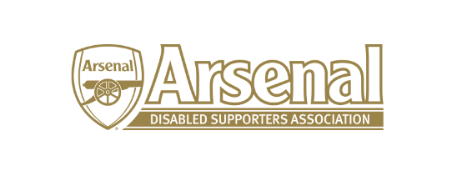

Arsenal Disabled Supporters Association

Committee Meeting

held on Wednesday 13th March 2019 – Skype Meeting at 7.30pm

Present: Anne Hyde (AH)
James Warren (JW)
Allan Mabbert (AM)

 | Item |  | Who to Action
1 | Apologies for Absence | Nicole Evans-Dear (NE-D), Redmond Kaye (RK), Anthony Joy (AJ), Tom Head (TH) and Ozi Kemal (OK)
2 | Approval of minutes of previous meeting | These will be approved at the next meeting on the 3rd April.
3 | Matters Arising from previous meeting | The Strategy Meeting had taken place between ADSA, Arsenal FC and Level Playing Field.
4 | Finance | NE had sent the financial report to AH. NE reported that the current account stood at £1,073.41 with no outgoings. A member had made a £50 donation to ADSA. NE asked that members of the committee who attended the Strategy Meeting to send her their expenses.
5 | Strategy Meeting with Arsenal FC and Level Playing Field | AJ, AH, RK, JW and AH attended the Strategy Meeting which was informative and worthwhile. AJ started by explaining that the strategy would be over 3 – 5 years and the meeting to focus on two aspects, the club and the supporters. The meeting was divided into two groups to discuss strengths, weaknesses, opportunities and threats. It was decided a separate meeting would be arranged to discuss the Arsenal FC website (Disabled Supporters page).  AJ had produced a document – Arsenal: Improving Access and Inclusion through the Years which outlined some of the changes since 2006. Alun Francis wished to add to this document and once it has been finalised, it will be published.  It was decided that a Survey would take place for all the season ticket holders and Purple members and Level Playing Field offered their help in producing this. The meeting felt that the survey should cover both home and away games and also have one for season ticket holders and one for Purple Members. The survey that Level Playing Field had produced was helpful and could be used as a guide.
6 | Annual General Meeting | The following members have indicated that they wish to stand – AJ, AH, JW, NE-D and AM. AH explained that everyone will need to stand again and that a Nomination Form will need to be completed. Committee Members will stand this time for two years (2019-2021). AH to remind committee members to let her know if they are standing.  The suggested date for the AGM is before the Brighton game on the 4th May from 12 noon – 1.30pm. AH to contact The Hub to see if it is free and will advise Committee and ADSA members.  AH said that the Constitution should be reviewed and will send out to everyone to comment. AM suggested that we appointed a Vice Chairman and as this is in the Constitution, we should either appoint or amend the Constitution. It was thought that having a Vice Chairman was a good idea.  Once the date for the AGM has been fixed, the Nomination Form and Constitution will be sent out to ADSA Members. | AH  AH  AH  AH
7 | Official Arsenal Supporters’ Club Scheme | There had been difficulty with members receiving their membership cards and AH is working with Arsenal FC to rectify this. Members will be informed once the cards have been printed.  All new members will automatically become official Arsenal Supporters’ Club members and the membership form has been amended accordingly.
8 | Primary League Advisory Group Update | AJ to give an update at the next meeting.
9 | Any Other Business | None
10 | Date of Next Meetings | Wednesday 3rd April via Skype – 7.30pm.  Provisional Date for AGM – 4th May at 12 noon.

Meeting closed at 8.50pm

