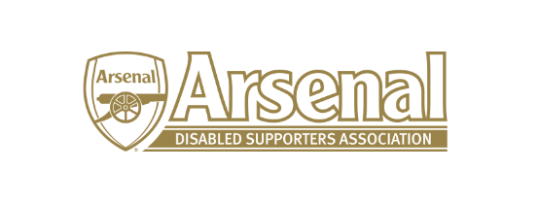

Minutes of the Arsenal Disabled Supporters Association

held on Thursday 4th May 2017 – Skype Meeting at 7.30pm

Present: Anne Hyde AH
Ozi Kemal OK
Nicole Evans (NE)
Allan Mabert AM
Anthony Joy (AJ)

 | Item |  | Who to Action
1 | Apologies for Absence | James Warren (JW)  Robert Greig (RG)  Redmond Kaye (RK)  Berenice Low (BL) -Invited
2 | Approval of minutes of meeting | There were no amendments to the previous minutes and therefore approved.
3 | Matters arising from previous meeting | This meeting focused on the forthcoming AGM. Matters arising from 30th March 2017 will be discussed at the next meeting.
4 | Finance | NE now has the information to set up the bank account and will do this as soon as possible. AH to assist.  It was agreed that as soon as the funds were transferred, we would become a full member of Level Playing Fields. | NE/AH  NE/AH
5 | Membership | AH reported that 131 people had signed up to the new ADSA – an increase of 10 since the last meeting. In total, the membership is now 184 which includes the old members that have not responded but paid the £10 membership fee.  18 members have confirmed they will be attending the AGM.
6 | Website | Some Committee Members have not yet sent their Bios and Photos to Ozi. This needs to be done as soon as possible and so that AJ can produce a poster for the AGM. | OK / RG / AJ / NE / RK
7 | AGM | AH said that she has arranged the AGM at The Hub for Sunday 21st May at 12.30pm. Doors will be open from 12 noon. We must vacate by 2pm. Tea and Coffee available.  Agenda to be amended to include Proposed Priorities, Questions to the Floor and JW to report on Communication (Website / Newsletter – Feedback and Suggestions).  AM was disappointed with the number who had confirmed their attendance and suggested that in future we look at having a guest speaker or link with an event.  AH to invite Mark Brindle and Alun Francis.  Kieran Reynolds (Level Playing Fields) has sent his apologies.  AH to send out the revised Agenda to the Committee and OK to post on the ADSA website.  AH to contact RK to see if he requires a Signer. | JW  AH  AH  OK  AH
11 | Any Other Business | None
12 | Date of Next Meeting | To be agreed

Meeting closed at 8.15pm.

