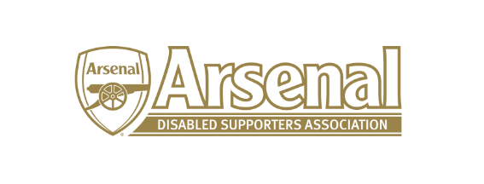
REDMOND KAYE – HEARING IMPAIRED REPRESENTATIVE

I am currently a purple member. I am deaf and have cerebral palsy and have been watching arsenal for 20 years. I attend all home game and some away games. I work for Citizens Advice in Hertfordshire helping deaf people.

