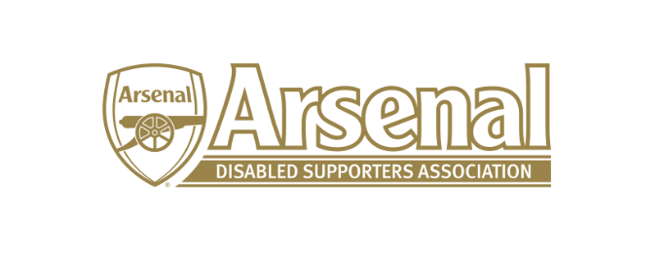
Arsenal Disabled Supporters’ Association

Notice is hereby given that there will be a meeting of Arsenal Disabled Supporters’ Association on Thursday 27th August 2020 from 7.00pm – 8.00pm via Skype.
Committee
Vacant (Chairman)
Anne Hyde (Secretary)
Nicole Evans (Treasurer)
Ozi Kemal (Media Officer)
Allan Mabert (Visual Impaired Representative)
Bob Greig (Committee Member)
Redmond Kaye (Hearing Impaired Representative)
James Warren (Newsletter Editor)
Vacant (Ambulant Representative)
Christopher Clelland
Steve Foord

Agenda
- Apologies for absence
- Approval of minutes of previous meeting
- Matters arising from previous meeting
- Resignations – Chair and Ambulant Representative (AH)
- Co-option of Chair / Committee Members
- Returning to the Emirates (JW)
- 2020 AGM (AH)
  - Date of Zoom AGM Meeting
- Raffle – First Team Shirt (NE)
- Any Other Business
- Date of next meeting

