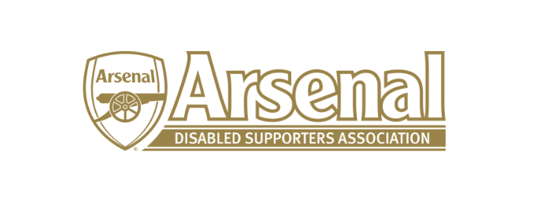
Arsenal Disabled Supporters’ Association
Notice is hereby given that there will be a meeting of Arsenal Disabled Supporters’ Association on Thursday 9th January 2020 at 7.30pm via Skype.
Committee
Anthony Joy (Chairman)
Anne Hyde (Secretary)
Nicole Evans (Treasurer)
Ozi Kemal (Media Officer)
Allan Mabert (Visual Impaired Representative)
Bob Greig (Committee Member)
Redmond Kaye (Hearing Impaired Representative)
James Warren (Newsletter Editor)
Tom Head (Ambulant Representative)
Christopher Clelland
Steve Foord

Agenda
- Apologies for absence
- Approval of minutes of previous meeting
- Matters arising from previous meeting
- Finance (NE)
  - Deposits and Payments
- Chairman’s Update – Meeting with Alun Francis (AJ)
  - Arsenal FC Website – Disabled Supporters page
  - Strategy
- Secretary’s Update (AH)
  - Membership update
  - Correspondence
- AFC Bournemouth – Correspondence (AJ/AH)
- ADSAs Website (AH)
- 2020 AGM
- Any Other Business
- Date of next meeting

