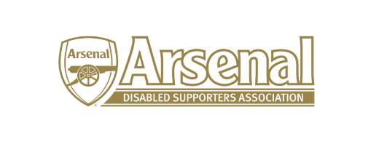

Disability Strategy Meeting
To be held in the Arsenal Disability Lounge, Arsenal Museum
On Monday 4th March at 9.30am for a 10am start
Attendees
Liam Bird (Fans Liaison Officer, Level Playing Field)
Mark Brindle (Supporter Liaison Officer, Arsenal FC)
Anita Crowley (Contact Centre Senior Team Manager)
Owain Davies (Chief Executive, Level Playing Field)
Alun Francis (Disability Liaison Officer, Arsenal FC)
Anne Hyde (Secretary, ADSA)
Anthony Joy (Chairman, ADSA)
Redmond Kaye (Hearing Impaired Representative, ADSA)
Allan Mabbert (Visually Impaired Representative, ADSA)
James Warren (Communications, ADSA)

Please note that Allan Mabbert will join the meeting via Skype

Apologies
Christopher Clelland (Hearing Impaired Member, ADSA)

- Welcome and Overview – Anthony Joy and Alun Francis
- Introductions - Attendees
- SWOT (Strengths, Weaknesses, Opportunities, Threats)
- 3 Year Vision
  - How are we going to get there?
  - Strategy Priorities
  - Four Pillars vs The Social Model of Disability
- Improving transparency
- Arsenal Website and Disabled Supporters Page
- Action Plan / Timescales
- Measuring success
- What is the most important priority moving forward?
- Next step?
Meeting will aim to close at 2.30pm
Refreshments will be provided – tea, coffee, biscuits, sandwiches and cakes.

