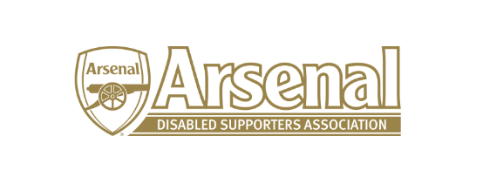

Arsenal Disabled Supporters Association

Committee Meeting

held on Thursday 27th August 2020 – Skype Meeting at 7.00pm

Present: Anne Hyde (AH)
James Warren (JW)
Nicole Evans-Dear (NE-D)
Allan Mabert (AM)
Christopher Clelland (CC)
Steve Foord (SF)
Tracey Clelland (Invited – Signer)

 | Item |  | Who to Action
1 | Apologies for Absence | Redmond Kaye (RK)
2 | Approval of minutes of previous meeting | The minutes from the meeting held on the 9th January 2020 were approved.
3 | Matters arising from previous meeting | AH reported that following the meeting held with Bournemouth, Watford and Arsenal in January, Bournemouth have made changes to the ground to ensure the safety of away supporters with disabilities.
4 | Resignations | AH informed the meeting that Anthony Joy and Tom Head had resigned. JW and AH to look at ‘A Thank You’ for Anthony for all the hard work working with Arsenal FC to improve facilities for supporters with disabilities at both The Emirates but also other premiership clubs over the past four years. | NE-D  JW / AH
5 | Co-option of Chair / Committee Members | It was decided that AH would take over as Chair (proposed by JW and seconded by AM), NE-D would stay as Treasurer, CC and RK would stay as Deaf/Hearing Impaired Representatives and SF will take over as Ambulant Representative (proposed by AH and seconded by CC).  A Vice Chairman, Secretary, Membership Secretary and Newsletter Editor need to be appointed. AH said that four people had come forward as possible committee members. AH to contact them to see what they can bring to ADSA and would ask if they could take on any of the roles. | AH
6 | Returning to the Emirates | JW updated the committee on returning to the Emirates following a meeting with Arsenal FC on the 21st August and a webinar that AH attended with LPF on the 19th August.  AM said that for visually impaired it could be problematic if their seats were changed. Also could the club give reassurance that season ticket holders will retain their seats post Covid 19 if they opt to not renew this season or possibly for 2021/2022 season?  NE-D asked what would happen if a supporter could not attend a match mid-week?  CC asked what if a carer is not part of your support bubble?  ADSA would like assurance that the stewards have been trained and that where possible clear visors are used and not masks especially where Deaf/Hearing Impaired sit.  All questions will be asked at the meeting on the 2nd September that JW and AH will be attending with Allun Francis (Disability Liaison Officer). | AH / JW
7 | 2020 AGM | It was agreed to hold the AGM virtually on the 24th September 2020 either via Zoom, Skype or MS Teams. CC said that there was no text facility available on Zoom. NE-D said that Skype and MS Teams does have that facility. AH to check how many people can be on Skype or MS Teams at any one time on the free version. | AH
8 | Raffle – First Team Shirt | A newsletter to be sent out to remind everyone to buy tickets and the raffle will be drawn at the AGM on the 24th September.  NE-D to update the committee as to how many tickets have so far been purchased. | JW  NE-D
9 | Any Other Business | NE-D suggested that everyone had more defined roles.  AM suggested we take stock of where we are as an association. JW will look at a strategy for ADSA and everyone to suggest three points to focus on over the coming year and send to JW. JW to email everyone with how he will approach the strategy.  AM asked why the Arsenal Website did not have colour contrast / enlarged text facility etc. AH said she had raised this previously and would raise it again with Alun Francis. | All  All  JW  AH
10 | Date of Next Meeting | 1st October at 7pm via Skype

Meeting closed at 8.25pm

