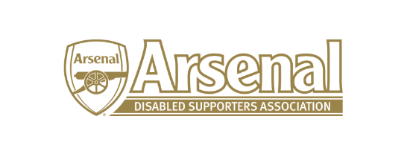

Arsenal Disabled Supporters Association

Committee Meeting

held on Thursday 9th January 2020 – Skype Meeting at 7.30pm

Present: Anne Hyde (AH)
James Warren (JW)
Tom Head (TH)
Anthony Joy (AJ)

 | Item |  | Who to Action
1 | Apologies for Absence | Nicole Evans-Dear (NE-D), Redmond Kaye (RK), Alun Mabbert (AM), Christopher Clelland (CC), Steve Foord (SF)
2 | Approval of minutes of previous meeting | These will be approved at the next meeting.
3 | Matters arising from previous meeting | None
4 | Finance | NE had sent the financial report to AH. NE reported that the current account stood at £751.94.  AJ said that we could apply for a small grant with CAFÉ. AJ to send information to AH.  AH had received the signed first team shirt for raffling. It was decided that the raffle will be advertised in February via the newsletter. | AJ  AH/JW
5 | Chairmans Update | A meeting with Alun Francis had not taken place and AJ will arrange this for as soon as possible.  There was no progress on the Access Statement. AJ to chase Alun Francis.  No progress had been made with the Arsenal FC website on improving the Disabled Supporters page. AH to speak with Alun Francis to arrange a meeting with Alun and the IT Department.  There was no progress on the 3 – 5 Year Strategy. AJ to pursue with Alun Francis and to suggest a further meeting.  It was felt that both the Disabled Supporters page on the Arsenal FC website and the Access Statement should be updated by the end of the season. | AJ  AJ  AH  AJ
6 | Secretary’s Update | Membership stands at 252 members.  A member had raised concerns regarding the delay in sending out tickets. AJ to ask Alun Francis the reason why tickets cannot be sent out at the same time as ambulant disabled. AH will also raise this through the Fans Forum / Supporters Club Forum.  A member had raised why able-bodied supporters are being allocated front row seats and ambulant supporters either 2nd or 3rd rows for away games. AH to raise this through the Fans Forum / Supporters Club Forum.  One member had been allocated a wheelchair space on the platform at Bournemouth but arrived to be told that the lift would not take electric wheelchairs. AJ to raise this with Alun Francis. | AJ  AH  AH  AJ
7 | AFC Bournemouth | Following some incidents at AFC Bournemouth, AJ had written a letter to AFC Bournemouth and Alun Francis. This raised issues around safety at AFC Bournemouth’s ground. An update will be given once further correspondence has taken place.  AJ will write to Bournemouth FC and Arsenal FC to as what reassurance they will be giving regarding safety for the FA Cup Game on the 27th January. | AJ
8 | ADSAs Website | AH said that it was now up and running and an article in the newsletter had been sent to our members.
9 | 2020 AGM | This could be held on either the 2nd May or 17th May. A final decision will be taken once the dates have been finalised.
10 | Any Other Business | The committee agreed that the Disability Liaison Team should have a database of ticket numbers for seats allocated for the disabled. It was felt that there was a lack of the team being proactive. AJ to follow this up with Alun Francis.  AJ to find out what is happening regarding sub-titles / signing on the screens prior to and after the matches at the Emirates.  AJ to add TH to the WhatsApp group | AJ  AJ  AJ
10 | Date of Next Meetings | To be agreed

Meeting closed at 8.55pm

