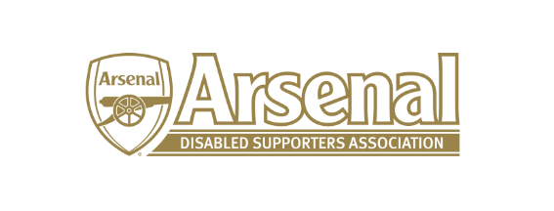
Steve Foord – Committee Member

I am currently a season ticket holder. I have a birth defect which needed several operations to my right foot as a child and left me with limited movement in my right foot and shorter right leg. I was sports mad growing up and active playing football for both school and Sunday league team as well as going fishing but these diminished over the years with pain out doing the pleasure. So my sporting interests are of the viewing nature from supporting the Arsenal to following F1, MotoGP and Boxing.

I have been fortunate to be following Arsenal from the late 80’s thanks to my Grandad, (rest of the family support the unmentionables and I have taught my daughters that it is a swear word ) so I have been spoiled through the Graham & Wenger years witnessing trophies and standards being set.

I attend all home games and some away games, I also attend Arsenal Ladies games with my daughters who are both Arsenal Ladies members.

