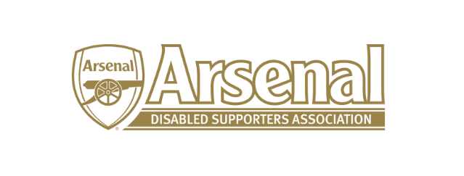
Arsenal Disabled Supporters’ Association
Committee Nomination Form

This is our fourth AGM and we will be electing our new committee. The current committee members are:
Chairman Anne Hyde (Co-opted)
Vice Chairman Vacant (this will be a member of the committee)
Secretary Vacant
Treasurer Nicole Evans
Membership Secretary David Pullen (Co-opted)
Newsletter Editor Vacant
Visually Impaired Representative Allan Mabert
Hearing Impaired Representative Redmond Kaye / Christopher Clelland
Ambulant Disabled Representative Steve Foord (Co-opted)
Media Officer Vacant
Committee Member James Warren
Committee Member Gordon Moser (Co-opted)
Committee Member Ly Chooong Voong (Co-opted)

All positions are for a two-year term and will run from September 2019 – September 2021 (this was decided at the 2019 AGM).
If you wish to stand for any of the vacant positions above, you are required to obtain a proposer and seconder and fill in the form below.
2020 – 2021 | Arsenal Disabled Supporters’ Association
I, the undersigned, wish to nominate the following person:
Name:
As (Position Title):
Proposer Name:
Seconder:

I am willing to be so nominated for the above position
Nominee Name:
Nominee Signature:
Date:

An electronic signature will be accepted. Please return the form to Anne – anne@arsenaldisabledsupporters.co.uk no later than the 15th September 2020.

