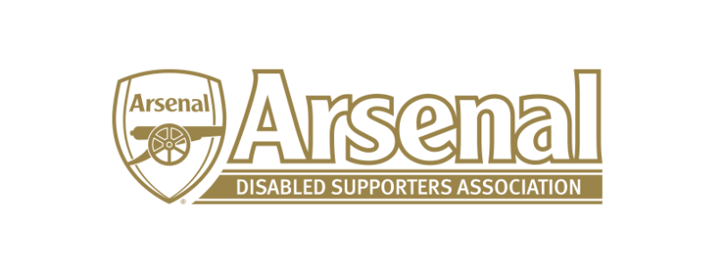

Arsenal Disabled Supporters’ Association
2020 Virtual Annual General Meeting

on Thursday 24th September 2020 from 7pm for a 7.30pm start

Agenda

- Welcome and Introductions (Anne Hyde)

- Apologies for Absence

- Approval of 2019 AGM Minutes

- Chair’s / Secretary’s Report (Anne Hyde)

- Treasurer’s Report (Nicole Evans)

- Priorities (James Warren)

- Proposed change to the Constitution - Membership
  - An ordinary member may be elected to become a Life Member at the discretion of the Committee and on election, have the rights of an Ordinary Member.

- Election of Committee Members
  - Secretary
  - Newsletter Editor

- Returning to the Emirates (James Warren / Anne Hyde)

- Questions from the Floor

- Any Other Business

- Raffle Draw

