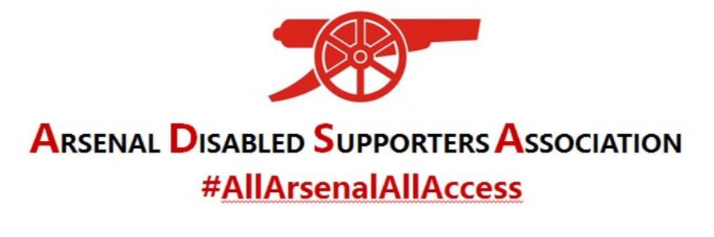
INSTRUCTIONS FOR MICROSOFT TEAMS
LAPTOP

It is highly recommended that if you have not used Microsoft TEAMS before that you download the app before the meeting and familiarise yourself with the programme by following the instructions below.

PRIOR TO THE MEETING
- Download the desktop app from https://www.microsoft.com/en-gb/microsoft-365/microsoft-teams/download-app
- To familiarise yourself prior to the meeting once you have downloaded the desktop app, click on MEETINGS on the left-hand side of the screen and then click on MEET NOW.
- You should get a similar screen to the one below. Click on Join Now

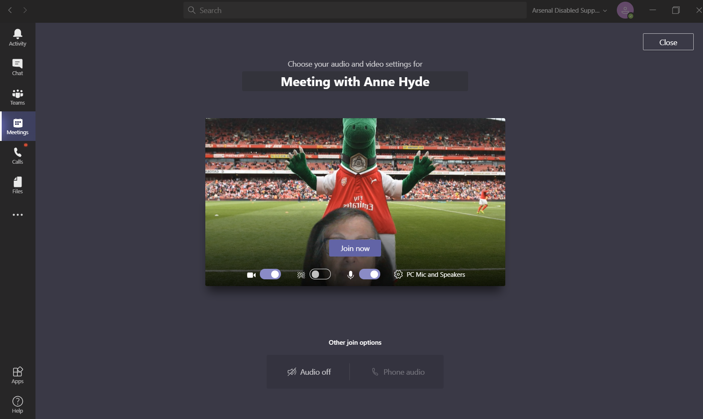

Note: If your screen looks like the one below then it means that your camera is off and your sound may be off too.

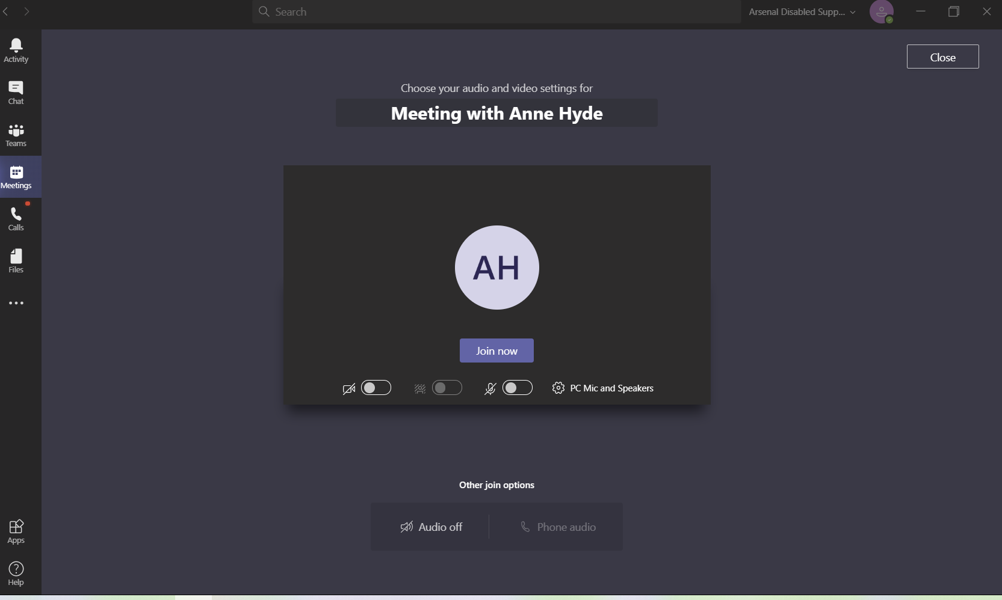
You will need to switch these on by clicking as shown below:

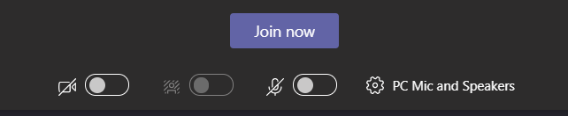

By clicking these this will turn on your video and sound and you will then get a screen appear similar to the one below:

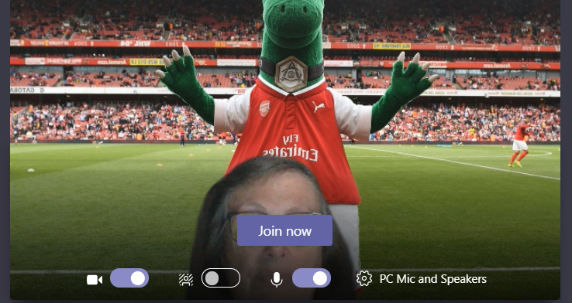

- Click on JOIN NOW.
- Move your mouse to find the toolbar that will give you more options.

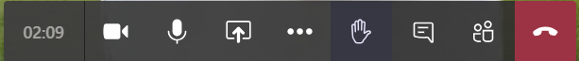

- Click on the three dots and the following screen will appear.

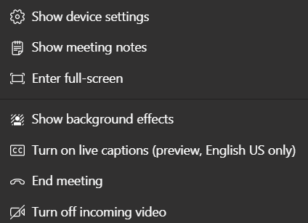

- If you want to TURN ON LIVE CAPTIONS – click on it and when you speak you will see the text appear at the bottom of the screen. This is useful for our Hearing Impaired members. To TURN OFF LIVE CAPTIONS just click on it again.
- If you want to change your background click on SHOW BACKGROUND EFFECTS. A toolbar appears on the right hand side of your screen and you can either select one of the images and click APPLY or you can click on + ADD NEW and add your own image. Note: You will need to scroll to the bottom to find your image you have added.

ACCESSING ADSA VIRTUAL AGM
- Click on the link for the meeting that has been sent to you via email or the link below:

Click here to join the meeting
The link can also be found on the ADSA website: https://arsenaldisabledsupporters.co.uk/annualgeneralmeetings/

- You may have to wait a few minutes while you are let into the meeting. Do not panic!

- You will be able to gain access to the meeting from 7pm on Thursday 24th September 2020 so that we can start promptly at 7.30pm. It will give you an opportunity to speak to fellow Arsenal supporters for the first ½ hour. The AGM is expected to last about one hour and the Raffle will be drawn during the meeting.
- If you are late coming to the meeting (after 7.30pm) we will be able to let you in.

