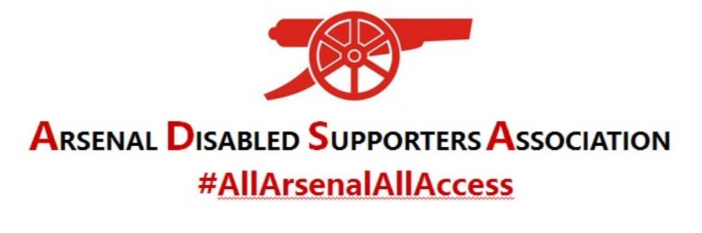
INSTRUCTIONS FOR MICROSOFT TEAMS
TABLET and MOBILE PHONE

It is highly recommended that if you have not used Microsoft TEAMS before that you download the app before the meeting and familiarise yourself with the programme by following the instructions below.
PRIOR TO THE MEETING
- Download the mobile app from https://www.microsoft.com/en-gb/microsoft-365/microsoft-teams/download-app
- To familiarise yourself prior to the meeting once you have downloaded the desktop app, click on CREATE A MEETING on the left-hand side of the screen.

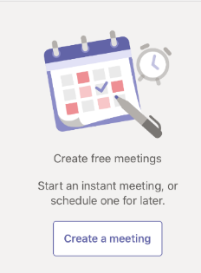

- The following screen will appear:

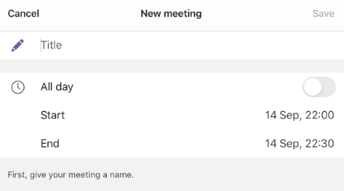

- Give your meeting a TITLE and select todays date and the current time. Then click on SAVE. The following screen will appear:
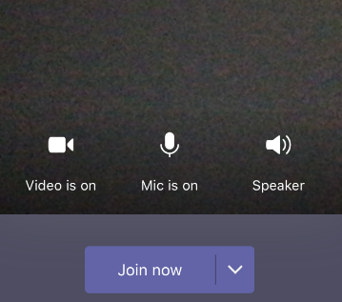

- You may find that the Video is showing OFF and the Mic is showing OFF. Click on both of these and this will turn them ON.

- Now click on JOIN NOW. This will join you to the meeting that you have set up.

- To access the toolbar, press anywhere on the screen and it will appear.

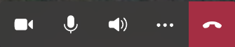

- Click on the three dots and this will give you further options – see below:

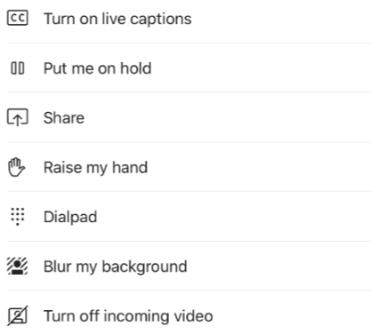

- For the Hearing Impaired you can TURN ON LIVE CAPTIONS which will show text so you will be able to read what people are saying.

ACCESSING ADSA VIRTUAL AGM
- Click on the link for the meeting that has been sent to you via email.

- You may have to wait a few minutes while you are let into the meeting. Don’t panic! You will be able to gain access to the meeting from 7pm on Thursday 24th September 2020 so that we can start promptly at 7.30pm. It will give you an opportunity to speak to fellow Arsenal supporters for the first ½ hour. The AGM is expected to last about one hour and the Raffle will be drawn during the meeting.

