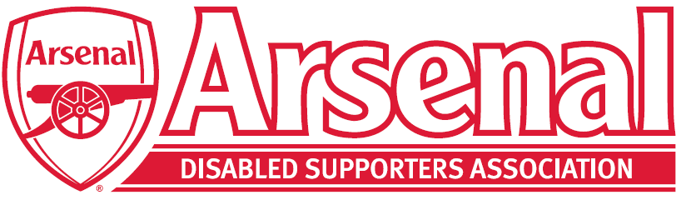

Committee Member Nomination Form
This is ADSAs fifth AGM and we will be electing our new committee. The current committee positions of the committee are:
Chairman
Vice Chairman
Secretary
Treasurer
Membership Secretary
Blind and Partially Sighted Representative x 2
Deaf and Hard of Hearing Representative x 2
Ambulant Disabled Representative
Arsenal Advisory Board Member
Committee Member
Committee Member
Committee Member

Under the ADSA Constitution all positions are for a two-year term and will run from September 2021 – September 2023. These positions are all up for election / re-election for the new term.
If you wish to stand for any of the positions above, you are required to obtain a proposer and seconder and fill in the form below.
2021 – 2023 | Arsenal Disabled Supporters’ Association
I, the undersigned, wish to nominate the following person:
Name:
As (Position Title):
Proposer Name:
Seconder:
I am willing to be so nominated for the above position
Nominee Name:
Nominee Signature:
Date:

An electronic signature will be accepted. Please return the form to Anne – anne@arsenaldisabledsupporters.co.uk no later than Friday 17th September 2021.

