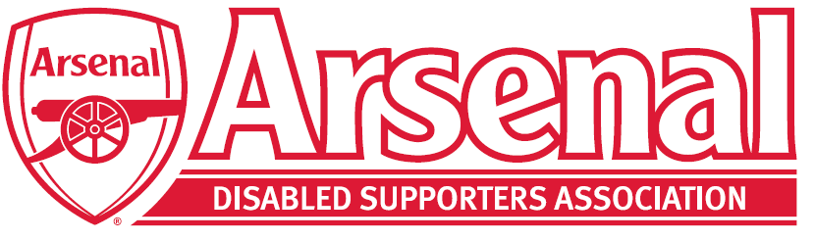
Arsenal Disabled Supporters’ Association
2021 Virtual Annual General Meeting

on Thursday 30th September 2021 from 7pm for a 7.30pm start

Agenda
- Welcome and Introductions (Anne Hyde)

- Apologies for Absence

- Approval of 2020 AGM Minutes

- Chair’s Report (Anne Hyde)

- Treasurer’s Report (Nicole Evans)

- Priorities (James Warren)

- Proposed change to the Constitution – Arsenal Advisory Board Member

From:
  - The ADSA Committee will comprise of three key positions which are the Chairperson, Secretary and Treasurer. There will be a minimum of one further member to be elected by members of the ADSA at the ADSA AGM.
To:
4.1 The ADSA Committee will comprise of three key positions which are Chairperson, Secretary and Treasure. Also the ADSA Representative on the Arsenal Advisory Board will be either elected or co-opted onto the ADSA committee for the duration they are the representative. There will be a minimum of one further member to be elected by members of the ADSA at the ADSA AGM.

- Election of Committee Members
  - Chair
  - Secretary
  - Treasurer
  - Membership Secretary
  - Arsenal Advisory Board Representative
  - Blind/Partially Sighted Representative x 2
  - Deaf/Hard of Hearing Representative x 2
  - Committee Member (General) x 3

- Questions from the Floor

- Any Other Business

- Raffle Draw

