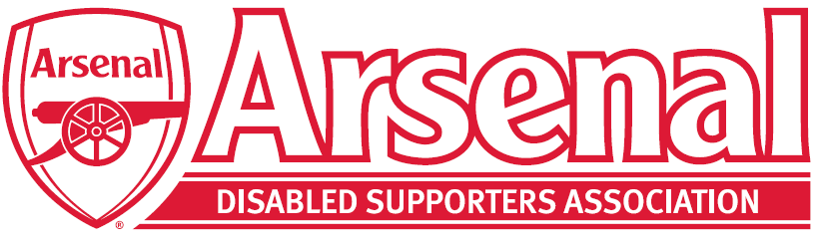
To all Arsenal Disabled Supporters’ Association Members
26th August 2021
Notice of the Fifth Annual General Meeting of the
Arsenal Disabled Supporters’ Association
Dear Member

This is to advise you of the upcoming Annual General Meeting of the members of Arsenal Disabled Supporters’ Association. The details of this meeting are as follows:

Date: | Thursday 30th September 2021
Time: | 7.00pm for 7.30pm prompt start
Place: | Virtual - Microsoft Teams

The Agenda will available to download from our Website nearer the time and will be sent out to all our members. At the meeting, members will have the opportunity to:
- Chat with other ADSA members and the outgoing / incoming Committee members (7.00pm – 7.30pm)
- Find out about ADSA’s operations and finances
- Ask questions about the operations and finances of ADSA
- Raise any issues that you would like us to raise with Arsenal FC
- Speak about any items on the Agenda
- Vote on any resolutions proposed.

At the meeting, members will be asked to vote to:
- Accept the Annual Financial Statements
- Elect Committee Members
- Vote on the proposed change to the Constitution

The proposed change to the Constitution is that 4.1 which states:
  - The ADSA Committee will comprise of three key positions which are the Chairperson, Secretary and Treasurer. There will be a minimum of one further member to be elected by members of the ADSA at the ADSA AGM.

To be changed to:
  - The ADSA Committee will comprise of four key positions which are the Chairperson, Secretary, Treasurer and the Arsenal Advisory Board Representative. There will be a minimum of one further member to be elected by members of the ADSA at the ADSA AGM.

An email will be then sent out nearer the time with the full details of how to access our AGM virtually as you will need to set this up on your laptop / tablet or phone.

We hope you will be able to join us for our second virtual AGM meeting.

Kind Regards

Anne Hyde
Chair
anne@arsenaldisabledsupporters.co.uk

