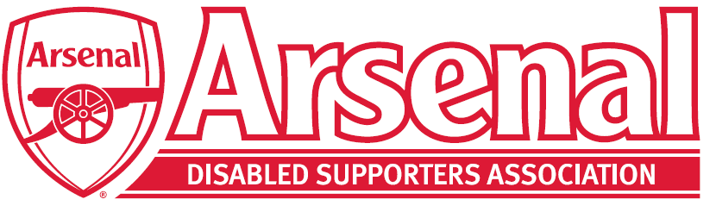

Arsenal Advisory Board
Election Process
for the
Arsenal Disabled Supporters’ Association Representative

At renewal time, the Arsenal Disabled Supporters Association (ADSA) or a time deemed by the ADSA committee will ask their members to make themselves known if they are interested in becoming the Arsenal Advisory Board Representative for ADSA.
Once applications have been received, ADSA will promote the individuals to their membership base. Then a ballot will be held to elect their representative for the following three years.
The ADSA Committee will determine when the vote for the secret ballot opens and closes. A reminder will be sent to all members during the voting period.
Members under the 18 years of age will not be able to vote.
Voting will be online via the ADSA website – https://arsenaldisabledsupporters.co.uk and you will need to include your email address and select the person who you want to represent ADSA on the Arsenal Advisory Board. Only the Chair will have access to this information.
Members can only vote once. Should a member vote twice then the first vote will count.
The person with the most votes will be the ADSA Advisory Board Representative. In the event of a tie, this will be decided by a toss of a coin at an ADSA Committee Meeting.
ADSA will share the results with their members as well as Arsenal Football Club.
The representative will sit on the Arsenal Advisory Board for a maximum of three years when s/he will be able to apply again in the next election process should s/he wish to do so. Should the representative leave before the end of the three years, then a further election process will take place immediately for the replacement.
Any questions or complaints regarding the election process must be addressed to the Chair, Anne Hyde by emailing anne@arsenaldisabledsupporters.co.uk

