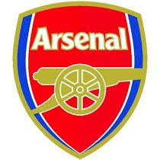
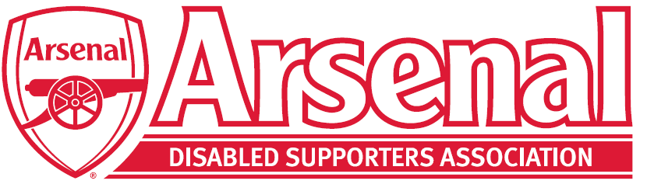

Arsenal Advisory Board
Terms of Reference

- Purpose
The purpose of the Arsenal Advisory Board (the “Board”) is to provide a forum for representatives from the Club’s supporters’ group and fanbase to meet with senior representatives from the Club and discuss relevant issues relating to the Club or football generally.

- Membership
The Board shall comprise the following members, representing the supporters:
- 1 representative from the Arsenal Independent Supporters’ Association
- 1 representative from the Arsenal Supporters’ Trust
- 1 representative from the Gay Gooners
- 1 representative from a UK-based supporters’ club
- 1 representative from an overseas-based supporters’ club
- 1 representative from the Arsenal Disabled Supporters’ Association; and
- 1 representative from the Fan Forum (18 to 24 years-old)

together the “Supporter Representatives”

The Board shall also comprise the following members, representing the Club
- an owner from the Club’s Board of Directors (currently Josh Kroenke)
- a further member of the Club’s Board of Director (currently Tim Lewis)
- the Club’s Chief Executive (currently Vinai Venkatesham)
- the Club’s Media, Communications & Community Affairs Director (currently Mark Gonnella); and
- the Club’s Supporter Liaison Officer (currently Mark Brindle)

together the “Club Representatives”.

- Selection and Replacement of Support Representatives
Each Supporter Representative will be elected by their own constituent group save for the following:
- The representative from a UK-based supporters’ club, who will be elected by the members of all UK-based supporters’ clubs
- The representative from an overseas-based supporters’ club, who will be elected by the members of all overseas-based supporters’ clubs; and
- The 18 to 24 year-old representative of the Fans’ Forum, who will be selected by the Club following an application process.

Each Supporter Representative shall remain as a member of the Board for a maximum of 3 years. At the end of those 3 years (or if a Supporter Representative leaves their constituent group or decides to stand down as a member of the Board during this time) a replacement Supporter Representative must be promptly appointed following the process described in this paragraph 3.

- Chairman
The Club will appoint the chair for each Board meeting. The chair’s responsibilities will include ensuring sufficient time is dedicated to each agenda item, input is sought from all members of the Board during each meeting, and a suitable number of both Club Representatives and Supporter Representatives are in attendance to form a quorum.

- Meetings
Meetings of the Board shall be held twice per season and at any other times as shall be necessary or appropriate, as determined by the Club in consultation with the Board. The Board shall meet in person and/or by telephone/video conference.

A duly convened meeting of the Board at which a quorum is present shall be competent to exercise all or any of the authorities, powers and discretions vested in or exercisable by the Board.

- Responsibilities
At each meeting the Board shall discuss any of the following key topics, as appropriate:
- the preservation of the Club’s culture and traditions, whilst celebrating its history
- the future direction and structure of the game, both domestically and in Europe
- any proposal for the Board of Arsenal Holdings Limited (the “Arsenal Board”) to approve the club joining a new league for competitive matches or the men’s first team playing ‘home’ matches at a venue other than Emirates Stadium
- the engagement and growth of the Club’s support around the world
- the Club’s continuing efforts to make a meaningful difference to those in need, in particular young people, through its community work in the UK and abroad
- the Club’s work on diversity and inclusivity, and in particular the continuing fight against online abuse
- the growth of the profiles of Arsenal Women and Women’s Football more generally
- the development of revenues to maximise investment in players; and
- any other topics as agreed by the Club in consultation with the Board prior to the meeting.

During each meeting, the Board may agree to pass recommendations to the Arsenal Board relating to any of the issues or plans discussed. Following each meeting, all such recommendations will be communicated directly to the Arsenal Board by a Club Representative. The Club Representative will keep the remaining members of the Board updated as to the status of any recommendation.

- Review
The Club shall in consultation with the Board, at least once a year, review the Board’s performance, membership, and these Terms of Reference to ensure it is operating at maximum effectiveness.

