MY ARSENAL REWARDS
LOYALTY POINTS CHECK

To check the number of loyalty points you have received you need to:
- Go to Arsenal FC Official Website | Home | Arsenal.com
- Click on the person in the top right-hand corner of the screen.

- Enter your membership number (not your email address) and your password. You will see that it shows your name and the number of points you have received, like the one below:

- To check whether you have received the correct number of loyalty points, make sure you are in https://www.arsenal.com and click back on the person.

- A box will appear showing your name, membership, loyalty points and when your card expires.

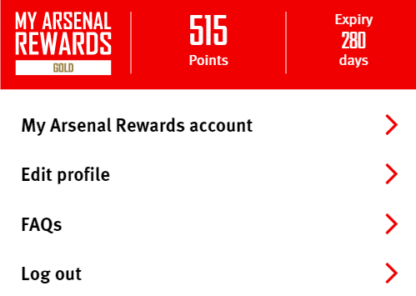

- Click on My Arsenal Rewards account.

- Click back on the person in the top right-hand corner of the screen.
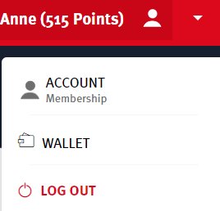
- Click on Account Membership

- Click on Activity (alongside Profile)

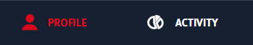

- Click on the calendar if you want to check points received prior to the date shown. For example change the date to the 1st July 2021.

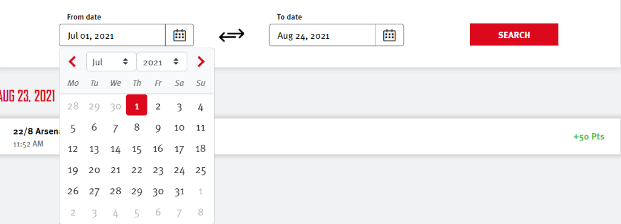

- Leave the TO DATE as the current date and then click SEARCH.

- If you scroll down it will show all the points you have received or spent. The received points will be in green with a + sign and the points you have spent in red with a – sign.

Note:
You only receive loyalty points for home games – none for away games. For home games you receive points if you attend a:
- Category A game – 50 points
- Category B game – 100 points
- Category C game – 200 points

Match Categories | Tickets & Membership | News | Arsenal.com – this link shows the Match Categorisation for the 21/22 Season.

If you use the prepayment option, you get 1 point for every £1 you spend with affiliates. More information on how you can earn points can be found here - My Arsenal Rewards

If you believe you have not received the correct number of points, contact myarsenalrewards@arsenal.co.uk

